CPNM Lab Assignment Day 6

# Interpolation numerical methods

Date – 18-01-2023 and 19-01-2023

1. Write a C program to find the value of
   1. sin(52) using Newton’s Forward Interpolation method given the following table

| A0 | 450 | 500 | 550 | 600 |
| --- | --- | --- | --- | --- |
| Sin A | 0.7071 | 0.7660 | 0.8192 | 0.8660 |

Example Output:

Enter the number of data:4

Enter the data

X1=45

Y1=.7071

X2=50

Y2=.7660

X3=55

Y3=.8192

X4=60

Y4=.8660

Difference table is:-

x Y ^1Y ^2Y ^3Y

45.0000 0.7071 0.0589 -0.0057 -0.0007

50.0000 0.7660 0.0532 -0.0064

55.0000 0.8192 0.0468

60.0000 0.8660

Enter the value x for function f(x):52

the value of function at x=52.000000 is 0.788003

* 1. f(1925) using Newton’s Backward difference method

given the following table-

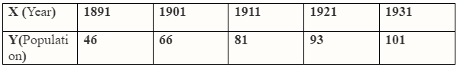

Example Output:

Enter the no of data:5

Enter the data:

X1=1891

Y1=46

X2=1901

Y2=66

X3=1911

Y3=81

X4=1921

Y4=93

X5=1931

Y5=101

The difference table

X Y ^1 ^2 ^3 ^4

1891.0000 46.0000 20.0000 -5.0000 2.0000 -3.0000

1901.0000 66.0000 15.0000 -3.0000 -1.0000

1911.0000 81.0000 12.0000 -4.0000

1921.0000 93.0000 8.0000

1931.0000 101.0000

Enter the value of x for f(x) 1925

the value of f(x) at x=1925.000000 is 96.836800

1. Write a C program to find the value of f(9) using Newton’s Divided difference method given the following table-

| x | 5 | 7 | 11 | 13 | 17 |
| --- | --- | --- | --- | --- | --- |
| f(x) | 150 | 392 | 1452 | 2366 | 5202 |

Example Output:

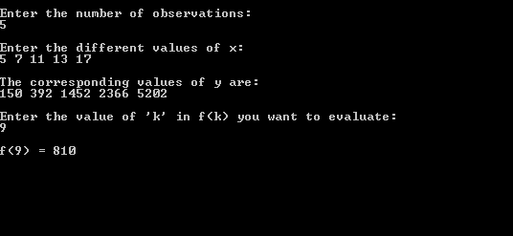

1. Write a C program to find the value of f(2.5) using Lagrange’s Interpolation method given the following table-

| x | 1 | 2 | 3 | 4 |
| --- | --- | --- | --- | --- |
| f(x) | 1 | 8 | 27 | 64 |

Example Output:  
 enter the value of n 4

enter the value to be found 2.5

enter the values for xi’s & fi’s

1 1

2 8

3 27

4 64

X = 2.500000

sum = 15.625000